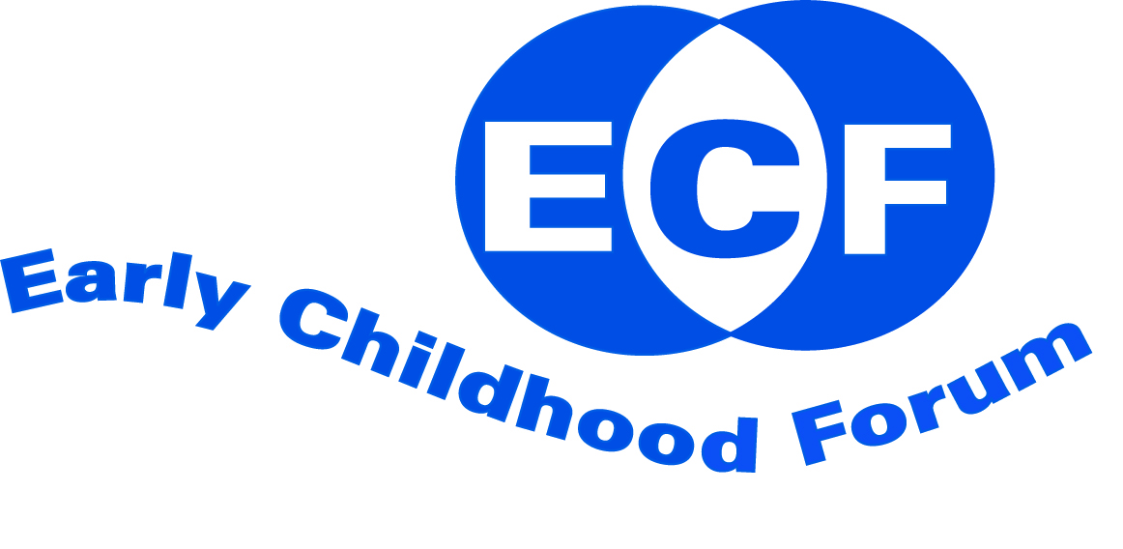

Early Childhood Forum

Policy Agenda

2015-2020

1. Introduction
Early childhood is a crucial stage of life, shaping long term physical and mental health. The Early Childhood Forum (ECF) aims to create an agenda for debate and action to ensure all babies and young children and their families are equally valued and supported. All ECF policy and practice is underpinned by the UN Convention on the Rights of the Child.
ECF is a voluntary organization. It is a coalition of around 40 professional associations, voluntary organisations and interest groups united in their concern about the health, well-being, learning and development of young children from birth to seven. ECF’s geographical remit is England, although it is recognised that member organisations may have a wider sphere of work.
ECF will challenge policy that is detrimental to children’s development and fails to uphold children’s rights.

The following document outlines the ECF's aims, principles and strategic objectives for 2015-20.

2. Vision
ECF believes inclusion is a process of identifying, understanding and breaking down the barriers to participation and belonging. ECF aims to bring together partners in the early childhood sector to promote inclusion and challenge inequalities, and to champion quality experiences for all young children from pre-birth to seven and their families and carers.

3. Activities

ECF will do this by:

- Providing support, advice and expertise on early childhood for the sector and Government.

- Building relationships with parents, carers and families and organisations in early childhood and Government.

- Supporting members’ professional development and sharing knowledge.

- Influencing local and national policy and practice to improve the experiences of all young children.

- Listening to children, their mothers, fathers and other carers, to influence ECF’s policy and activities.

- Using evidence from research to better understand the developmental needs of babies from conception through to age seven.

- Developing resources, initiating and supporting projects with partner organisations.

- Reviewing ECF’s ability to influence policy and practice.

4. Objectives
ECF has five central areas of work which form the basis of its policy agenda:
- Championing children’s rights and entitlements
- Supporting training, development and professional education in early childhood
- Promoting working in partnership
- Addressing inequalities and valuing diversity
- Evaluating practice and ensuring quality.

4.1 Championing young children’s rights and entitlements

ECF believes that

- All children are entitled to participation, high quality provision, opportunities to play and protection, as outlined in the UN Convention on the Rights of the Child.

- The needs of the child must be placed at the centre of policy, planning and provision to enable them to enjoy and achieve and realize their talents.

- The emotional well being of children is central to every aspect of children's development, learning and family life.

- Learning is a process of development through play, interaction and experience which begins before birth.

- All children from birth to seven should have equal access to a culturally and developmentally appropriate play-based approach, both indoors and outdoors.

- All children are entitled to opportunities and experiences that support and extend learning and develop their understanding, dispositions, skills and knowledge.

- Consistent, sensitive care which includes listening and responding to children is fundamental if babies and children are to thrive in the home and other settings.

- All children have a right to inclusion and participation alongside their peers in environments that are free from discrimination.

- All children have the right to be protected from harm and maltreatment in the home and wider community.

4.2 Supporting training, development and education in early childhood

ECF believes that

- Access to appropriate and relevant high quality training and education and remuneration is essential for all those working with infants, young children and their families.
- Continuing training and professional development should be available and accessible to enable all those that work with babies and young children to sustain and improve the quality of their practice through review and reflection, building on previous training and qualifications, and current research.
- There should be a higher level of recruitment and retention of under represented groups in early childhood than currently exists.
- All work places should develop policies that actively facilitate the involvement of all staff in appropriate training, development and education opportunities.
- Training must ensure that a well qualified practitioner is able to understand personal prejudices and institutional discrimination.
- There should be training regarding regular and meaningful consultation with mothers, fathers and carers, and how to encourage parental participation in an equal relationship alongside practitioners.

4.3 Promoting working in partnership

ECF believes that

- It is essential to strive to develop an equal partnership and strong working relationships with members, observers and policy makers.
- The role of mothers, fathers, carers and the wider family is critical at all stages as their relationship with the child is key to the emotional well-being, early brain development and learning of their children. A partnership approach should be embedded in all aspects of health and education provision for young children, including policy making, based on an understanding of mutual rights and responsibilities.
- A strategic approach is needed at national, regional and local levels to ensure that policy development and implementation is coherent and co-ordinated, so making best use of available resources.

4.4 Addressing inequalities and valuing diversity

ECF believes that

- Inclusion is a process of identifying, understanding and breaking down the barriers to participation and belonging.
- Strategies should be in place demonstrating that all children and their families are equally valued, supported and respected.
- A full range of support should be available in all local authority areas for all children to ensure full participation and inclusion, and support in the home environment through home visiting and outreach services to assist the parents and other significant care givers.
- Policy, procedure and practice should be anti-discriminatory, challenging stereotypes and positively valuing diversity.
- Individuals should have ongoing opportunities to reflect on and find strategies to challenge personal prejudices and institutional discrimination.

4.5 Evaluating practice and ensuring quality

ECF believes that

- Continuous quality improvement, which includes consistent responsive age appropriate care provision and services, is the basis for improving children’s health, well-being, learning and development.
- All those who work with babies and young children should monitor, evaluate, challenge, develop and reflect on their practice continuously.
- Children and their parents must be fully consulted and involved in evaluation processes through regular dialogue and participation.
- Quality improvement must be based on agreed quality principles
- All practitioners should be involved in quality improvement processes
- Findings from research and evaluation of practice should underpin policy development.

Note. Throughout this document, the definition of ‘early childhood’ encompasses the period from conception to age seven.

The policy agenda was initially agreed by the Early Childhood Forum on 20 July 2006. This revised version was signed off on 25 March 2015 and will be reviewed annually.

More information
Visit the ECF website at www.earlychildhoodforum.wordpress.com
Contact the Chair, Melian Mansfield on earlychildhoodforum@yahoo.co.uk

